Introduction to self-driving car
This report will introduce the basis knowledge about self-driving car, and focus on the process and accomplishment of machine learning on self-driving car.

1)
Introduce to self-driving car
What is self-driving car?
The way self-driving car work is basically similar with Intelligence. Because the definition of intelligence is that intelligence exist in an environment, and it has set of sensors to do perceptions, in order to achieve some goals, it start to gather information through sensors, then it begins to process such information to make judgement and decision, and finally makes action through effectors to achieve goals.
This diagram below show such step.
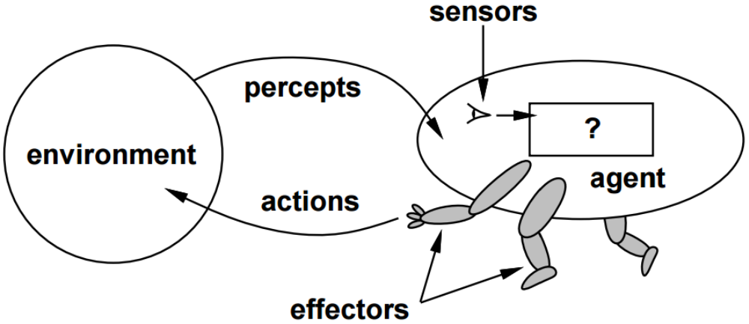
How such way work in self-driving car?
Sensor:
On self-driving car, there are lots of sensors from both external and internal of car.
E.g.
External
- Rader
- Lidar
- Infrared camera
- GPS
- Audio
Internal
- Visible-light camera
- Audio
(Note: Audio is extremely important for self-driving car, because it can receive some information that visual can’t receive, for example, whether that is not raining, but the road is still wet.
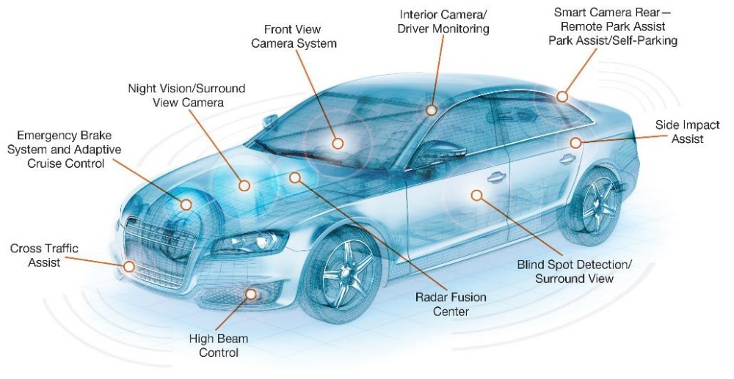
Goals and outcomes of information:
Goals: to arrive safely destination which driver want to arrive.
Outcomes:
Localization and Mapping, Scene Understanding, and Movement plan.
After process information, self-driving car should be able to answer where am I? and what is surroundings ? and How do get from A to B?
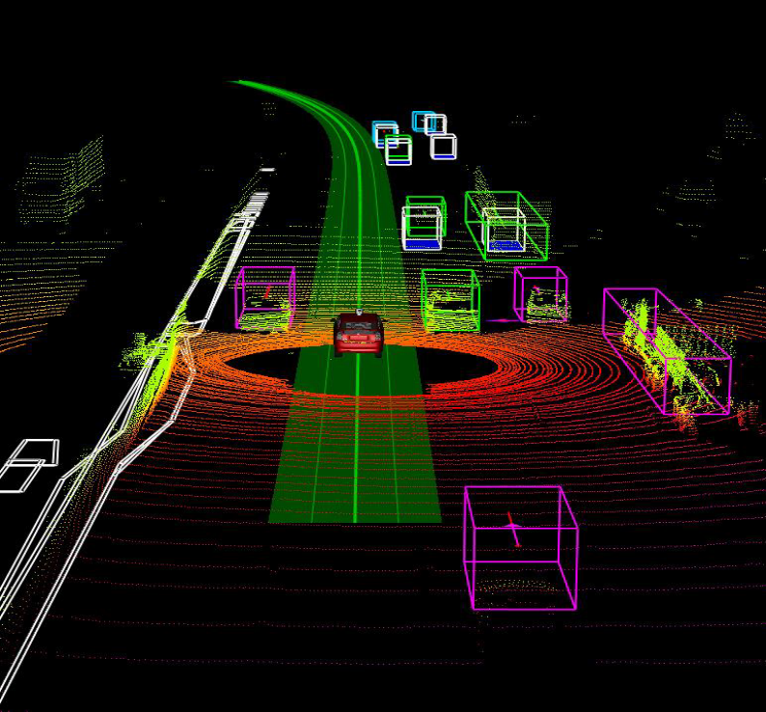
Final goals are to form a safe route for car, and control that car to move on such route to accomplish what driver’s destination.
Why people need self-driving car?
It is a obviously question with answers. Because human are not good at driving, but driving is a crucial part of life, it is necessary to invent self-driving car to replace driver. There are 35092 people died in 2015 in US because car accident.
How to accomplish self-driving car?
Now, self-driving has been research by several company such as Google(Waymo), Uber, noTonomy, Tesla Autopliot.
Because the uncertainty of driving, it is impossible for programmers to set rules for self-driving as usually. Even though, there are bunch of programmers can built such program, the database will be too heavy and big to put on cars. Therefore, scientists are researching instead to set rule for self-driving car, how to let self-driving know which action is better, and make decision by it own. That is machine learning in self-driving car.

2)
Machine learning in self-driving car
What is machine learning?
Machine learning gives computer the ability to learn without being set rules (explicitly programmed) for computer. Also machine learning is highly related to computational statistics, which also focuses in prediction-making through the use of computers.

Recent breakthrough in Machine learning : artificial neuron system
Neuron is computational building block for “neural system”.
Neural system is a system receive a set of input through serval neurons, process data from other neurons which built by some activation function, and finally to produce a 0/1 output for computer.
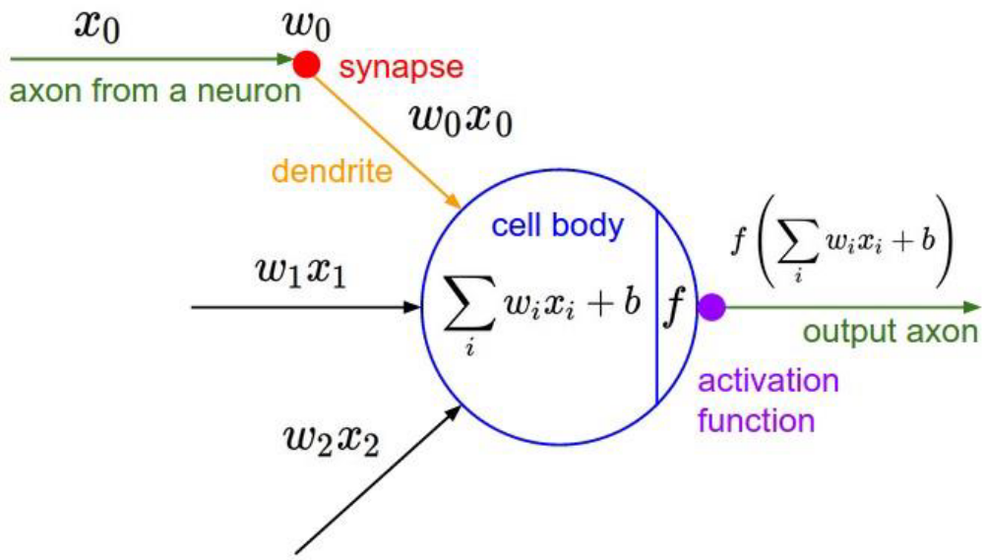
Compared to human neural system, artificial neuron system lacks reasoning logical deduction, but the advantages of artificial neuron system are they are good at learning from data, even though they can’ t understand the meaning and method for such algorithm.
Currently, scientists are using such system to machine learning. Scientists instead of setting rules for each neuron, they only input inputs and outcomes to such system, and let the system determine which neuron should be use or how to set each of neuron. If such system can correctly use different neurons or correctly set each neuron in the system, they can get rewarded from it. Then use such setting/system from last time to apply to next input, if the answer is correct then the next input. However, if the answer is not correct, then neural system itself going to reset part of neural system or add a new neuron and get punish from it, then try next input. As long as keeping looping it, , the whole neural system can be formed. After formation of neuron system, it can due with uncertain input and give a reasonable outcome. Though such outcome probably is not extreme accurate, it is similar with ideal outcomes.
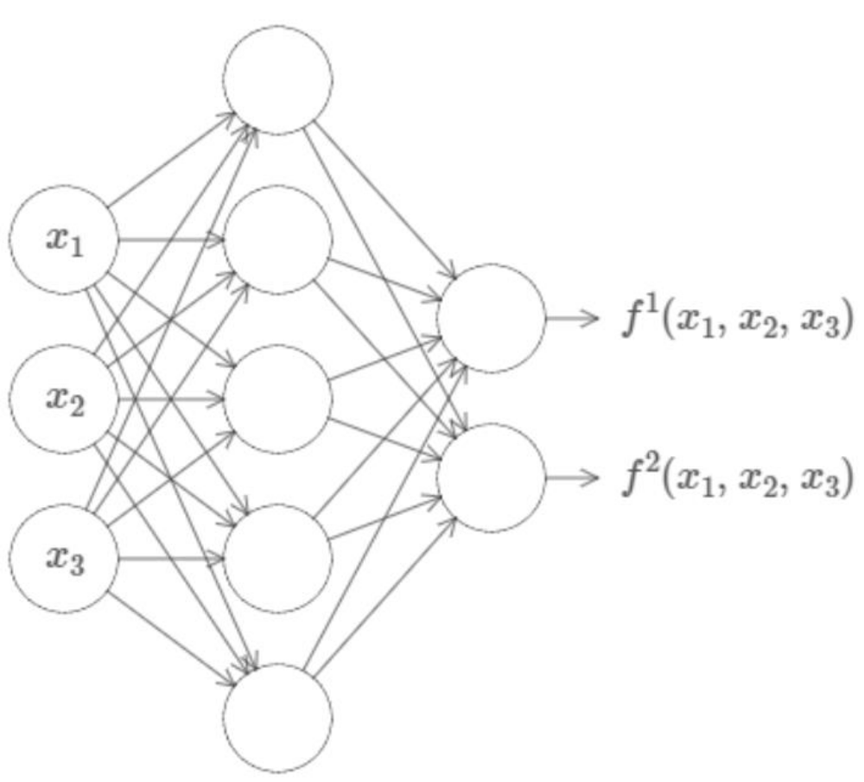
E.g.
Science input the number of Bedrooms, Sq. Feet and number of neighborhood randomly to an artificial neural system, and give the final price estimation for such real estate. If such neural system can answer the outcomes correctly, it can get one point for it. Keep looping to form neuron in neural system. At the beginning, this system don’t know anything about real estate estimation, but such process, it become a relatively accurate real estate estimation system.
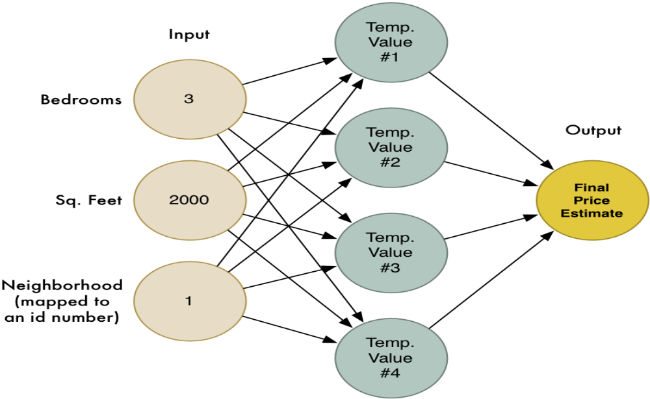
Such system is called deep learning.
Current Drawbacks:
Lacks reasoning: Humans only need simple instructions, and learn from simple examples. E.g. when people learn math. Because is original system, this system don’t know any thing about concept of math, concept of adding, subtraction, etc. Programmers must give it such knowledge.
Requires big database.
Need to manually select network structure, programmers must build a structure for artificial system.
Needs to hyperparameter tuning for training.
It is difficult to define a good reward function for neural system.
E.g. self-driving form a safe cycle route instead of achieving the final goal which go to certain destination which driver asked for. On one side, it indeed complete a goal to form a safe route for car, on the other hand it ignore the final goal. The precedence of final goal is lower than safe route in the this reward system. However, in some time, form a safe route is more important than the final goal.

How deep learning apply on self-driving car?
Because the uncertainty of driving, it is extremely important to form a program which can due with uncertain inputs.
What is the process of self-driving car?

